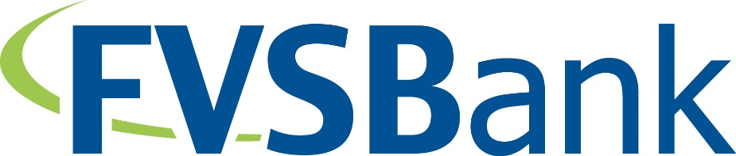

FOR IMMEDIATE RELEASE December 29, 2021
For more information, contact:
Kirsten Quam
kquam@fvsbank.com

FVSBank names Steven R. Walber President and Chief Executive Officer

FOND DU LAC, WI – The Board of Directors of FVSBank has named Steven R. Walber President and Chief Executive Officer effective July 1, 2022.

“We are very pleased that Steven will be leading FVSBank as its President and CEO,” said Steven R. Schmudlach, Chairman of the Board. “Steven has been instrumental in leading FVSBank’s strategic efforts these past few years, positioning the Bank for future growth and opportunity. He is an intuitive and strategic leader, bringing more than 30 years of comprehensive experience to his new position. His extensive background will provide the strengths and resources needed to lead FVSBank forward in our communities while maintaining the Bank’s core values.”

Walber joined FVSBank as Senior Vice President and Chief Credit Officer in June of 2015 and was promoted to Executive Vice President in January 2020 and President in March 2021. Throughout his banking career, Walber has been active in community efforts. Currently, he serves as a board member and volunteer for the Fondy Food Pantry, is an active member with the Envision Greater FDL MIT Committee and is highly engaged with the Fond du Lac Morning Rotary Reader program and Diversity in Reading program.

###

For more information about Fox Valley Savings Bank services, visit https://www.fvsbank.com/

FVSBank is a community-minded mutual bank, Fox Valley Savings Bank has been providing Oshkosh, Fond du Lac, and Waupun with quality services since 1934. FVSBank is a local bank: This means quick, local decision-making and true community partnership. The Bank continues to enhance and expand its banking services since 1934 while serving the banking needs of its communities.

