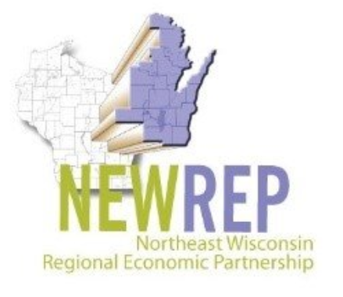
FOR IMMEDIATE RELEASE
Media Contact: Mary Rhode, Director of Marketing, 920.370.9515, mrhode@greatergbc.org

Northeast Wisconsin Regional Economic Partnership (NEWREP) Releases Manufacturing Industry Benefits Survey Results
GREEN BAY, WIS. (Aug. 8, 2022) — The Northeast Wisconsin Regional Economic Partnership (NEWREP), together with KerberRose, has received the results of its Benefits Survey. In May 2022, the following economic development organizations assisted in communicating the survey request to manufacturers in their respective geographic areas.

- Door County Economic Development Corporation
- Envision Greater Fond du Lac
- Fox Cities Chamber of Commerce
- Greater Green Bay Chamber
- Kewaunee County Economic Development Corporation
- Marinette County Development & Tourism
- NEW Manufacturing Alliance
- Oshkosh Chamber of Commerce / Greater Oshkosh EDC
- Shawano County Economic Progress, Inc.
- Sheboygan County Chamber
- Winnebago County

The purpose of this survey was to gather comparative data and uncover benefit offerings which may need to be addressed in order to both retain the current workforce and attract new employees. The results will serve to support manufacturers in securing the workforce needed to drive their success.

"While wages are still a key consideration for many job seekers, benefit packages have become a difference maker to many who are making employment decisions,” said Peter Thillman, Chair of NEWREP. “In today's super competitive hiring environment, NEWREP's survey reveals standard regional benefit levels assisting local employers to better understand the benefits offered by other local employers."

The survey received 191 respondents which represents nearly one third of the approximately 600 manufacturers in Northeast Wisconsin that have 25 or more employees and report revenues of $3 million or more.

Survey respondent demographics:
- 85.64% came from privately owned operations, with 77.19% of respondents reporting revenues greater than $5 million and 92.98% with revenues over $1 million.
- 62.77% of organizations have fewer than 200 employees, 21.28% have 100-199 employees, and 15.96% have 1,000+ employees.
- Responses indicate 77.42% come from an environment where more than half of their workforce is non-union.
- 74.19% of respondents come from a demographic of more than half of their workforce being hourly.
- Nearly 100% have an employee population identifying as white and 26.11% as Hispanic, indicating a non-diverse population.

The survey results revealed an overall positive outlook on Northeast Wisconsin employers and the benefits packages they offer to their employees.

“The greatest competitive advantage and asset of every company is its workforce," said Rita Belov, Talent Acquisition Manager with Sofidel America. “Provide them with great Employer Value Propositions (EVPs), such as training & development, career advancement opportunities, financial & achievement rewards, workplace autonomy, and of course, a generous medical benefits package, aggressive 401K match, visa sponsorship and a relocation package to attract and retain top talent.”

Survey respondents' areas of excellence:
- Nearly all companies indicated they provide regular compensation increases, particularly based on merit and market indicators.
- 100% of respondents provide paid holidays.
- Nearly 66% (65.56%) of respondents pay out accrued, unused vacation.
- Employees are vested sooner than 5 years at many companies, which is faster than national averages.
- Nearly all companies surveyed (96.47%) offer medical insurance, a make-it or break-it item for many employees.
  - Disability and life insurance in addition to some form of retirement offerings are also offered by most.
- 78.79% of respondents offer an Employee Assistance Program (EAP)

“This study gives NEWMA members and other manufacturing companies the opportunity to analyze how their benefits compare to other companies in the region,” said Ann Franz, Executive Director of the NEW Manufacturing Alliance. “I’m excited that many companies reviewing this study will learn of benefits they never thought of offering and seeing that these unique benefits are being utilized at other companies.”

Knowing that not all employers can provide all recommended benefits due to budget constraints, here are the top three suggested benefits:
- Hiring Bonus
  - 59.76% of companies responding do not offer any kind of bonus to new hires. Not including this employee perk may prove detrimental to recruitment efforts.
- HRA/HSA
  - Nearly half of respondents do not have a plan in place, yet this is a budget-friendly option to round out your benefits package.
- Paid Time Off (PTO)
  - Survey results show 16.02% of respondents do not provide PTO. While federal law does not require employers to provide this benefit, doing so could increase employee morale and prevent burnout.

Other surprising statistics:
- 56.96% do not provide any Childcare Assistance
- Excluding short-term disability, 65.85% of respondents do not offer any paid maternity leave
- 74.25% do not provide domestic partner benefits
- Only 22.09% of employees are eligible to contribute to their retirement plan at 90 days

###

______________________________________________________________________
Established in 1882, the mission of the Greater Green Bay Chamber is to strengthen member businesses, enhance economic and workforce development, and improve the quality of life in our community and region. For more information, call 920.593.3400 or visit greatergbc.org.

